Animals of the Rainforest

The rainforest is a perfect place for many types of animals to live. It is warm all year. There is plenty of water, shelter, and food. Insects in the rainforest can grow all year because there is never any winter. Some insects grow very large. Beetles can be as large as your hand. 200 different kinds of insects can live on one tree!

Birds
Rainforests are also home to many kinds of birds. These birds are large, colorful, and noisy. Rainforests are not quiet places. Visitors hear the calls of the birds and the buzz of the insects.

Reptiles and Amphibians
Many reptiles and amphibians live in the rainforest. Many snakes are found there. The scariest snake might be the anaconda. The anaconda can grow to more than 20 feet long. It crushes its prey then swallows it whole. Frogs are common in the rainforest. If a frog is brightly colored, it is probably poisonous.

Mammals
The rainforest houses many unusual mammals. The most common mammals are bats. Rodents are also common. Some rats grow larger than German shepherds. Monkeys and apes love the rainforest. Jaguars and tigers are two of the largest animals in the rainforest.

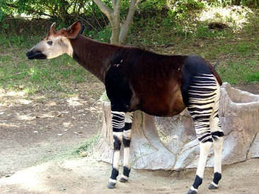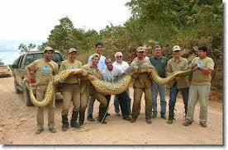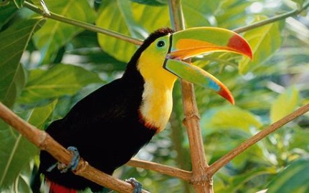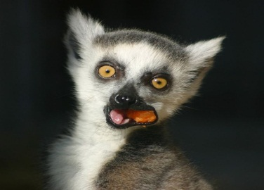
okapi anaconda toucan lemur

Animals of the Rainforest
Location | Height | Conditions | Animals
Overstory | 150 feet and above | - Much sunlight | Insects, bats, birds, Harpy eagles
Canopy | 100 – 150 feet | - Less sunlight  - Water is trapped in leaves | Insects, spider monkeys, sloths, orangutans, parrots, toucans
Understory | 0-100 feet | - Little sunlight  - Humid | Insects, birds
Floor | 0 feet | - Very dark  - Rotting plants | Insects, jaguars, okapis, Bengal tigers, snakes

The Vanishing Rainforest
Imagine 500 football fields. This is how many 500-football-field areas of rainforest were destroyed between 1990 and 2005!
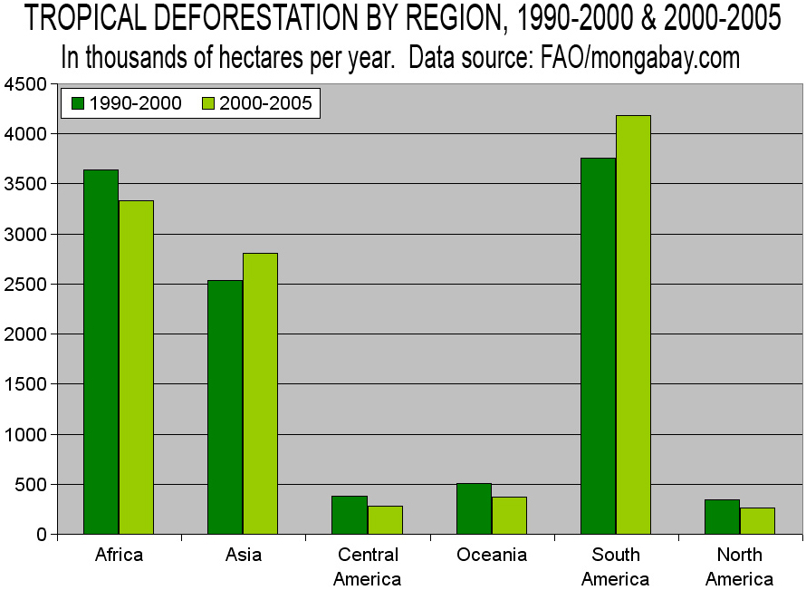
Tropical rainforests are in danger! Every year, more rainforest is destroyed.

3 Threats

- Humans (building roads, clearing land for farms, using wood for paper)
- Droughts (long periods of time with no rain)
- Forest fires (when the forest is dry, it can burn)

