**Tropical Rainforests**

**Important Facts**

* There are 250,000 kinds of plants in the world. 170,000 of them live in rainforests.
* The United States has 81 kinds of frogs. One rainforest has 500 kinds of frogs.
* In the United States, an area the size of a football field has 20 kinds of trees. A rainforest has 400 kinds of trees in the same area.
* Europe has 570 kinds of butterflies. A rainforest has 1300 kinds of butterflies.

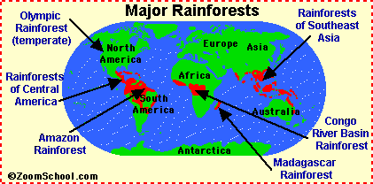

Information compiled from [www.kids.mongabay.com](http://www.kids.mongabay.com) and the International Children’s Rainforest Network.

**The “Lungs of the Planet”**

All plants take in pollution. They turn this pollution into clean air. Plants turn ***carbon dioxid***e into ***oxygen***. All living things need oxygen.

Rainforests make more oxygen than other forests. They have more trees than other forests. The trees are taller. The tall trees block the sun. Many other plants grow on the rainforest floor. The trees and other plants produce oxygen. Tropical rainforests have been called **“the lungs of the planet.”**

The tropical rainforest. The trees are very tall. Notice the canopy 100 feet above the ground.

**What are tropical rainforests?**

Tropical rainforests are a special kind of forest. They have very tall trees. They are found in warm climates. Rainforests get lots of rain. Some rainforests get more than 1 inch of rain every day.

The trees in rain forests grow tall and close to each other. Their branches and leaves touch. This makes a place where animals can live high above the ground. This place is called the ***canopy.***

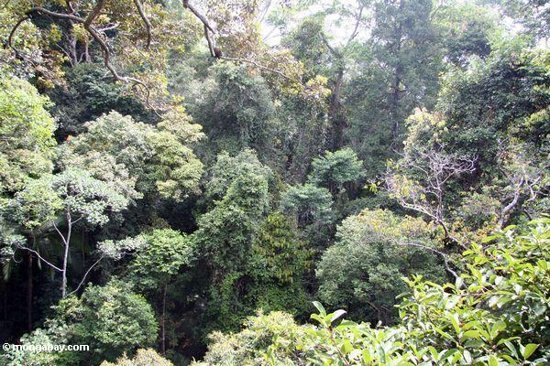 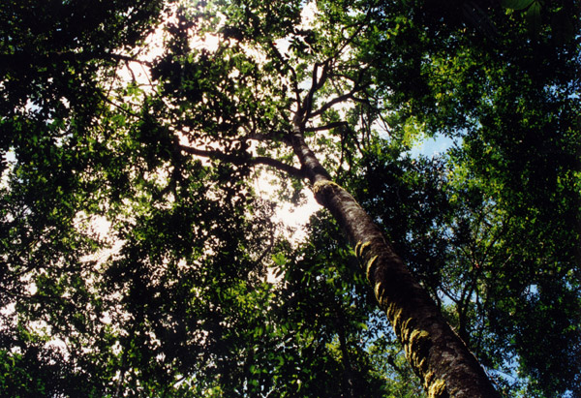

The canopy from above. The canopy from the floor.

Many different plants and animals live in rainforests. They have a special relationship. They support each other. Rainforests show us how animals and plants work together to survive.

**Why are tropical rainforests special?**

Rainforests cover only 2% of the world’s surface, but they are very important. These facts show why:

**Facts about Rainforests**

